### projects

* **Medical Record Management System (2019):** This project is based on making a program in C language which maintains records of medicines available in the store. It has features to add new stock, delete previous stock, auto update quantity of stocks remaining after sale.

### 

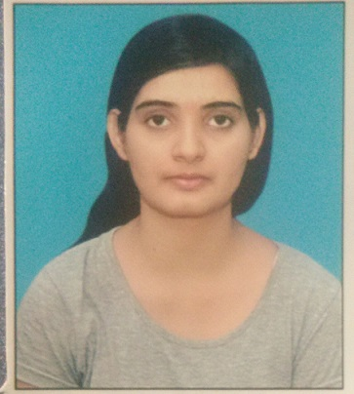

SONAM

# sUMMARY

Well-versed in numerous programming languages including C, JAVA, MySQL. Strong background in project management.

## Skills & Abilities

* Project Management
* Strong Decision Maker
* Innovative
* Service Focused

## Vitals

**Address:**

Hetampura, Bhiwani, Haryana (127029)

**Phone:**

+91 9306408354

**Email:**

sonamtanwarxyz@gmail.com

### Education

**Master of Computer Application**: (2019-2022) J C Bose University of Science and Technology

Current CGPA- 7.4

**Bachelor of Science**(Computer Science): (2016-2019) Adarsh Mahila Mahavidyalaya, Bhiwani, Haryana

Result- 68.7%

**Intermediate:** CBSE Board(2016) Delhi Public School, Bhiwani, Haryana

Result- 62.3%

**High School:**  State Board (2014) R G V D High School, Bhiwani, Haryana

Result- 90.2%

### Languages

English

Hindi